Pig Hands-On Exercise — Log Analysis Using Apache Pig

1. Objective
The objective of this exercise is to perform log data analysis using Apache Pig in both Local Mode and Hadoop MapReduce Mode.
The exercise demonstrates:
- Loading log data using PigStorage()
- Filtering records using FILTER
- Grouping data using GROUP
- Aggregating data using COUNT() and SUM()
- Performing JOIN operations
- Using built-in functions such as MATCHES and UPPER()
- Storing results in HDFS using STORE
- Executing Pig programs in batch mode using a .pig script

2. Procedure

Part A — Local Mode

Step 1: Start Pig in Local Mode
Pig was started using:
pig -x local
The local execution mode allows Pig programs to run without requiring Hadoop HDFS.

Step 2: Create Sample Log Data
A sample log file was created at:
/home/mahi/sample_logs.txt
The file contained:
192.168.1.1,/index.html,200,1024
10.0.0.2,/submit,404,50
192.168.1.1,/style.css,200,512
10.0.0.3,/index.html,404,20
192.168.1.1,/script.js,200,2048
10.0.0.2,/login,200,256

Step 3: Load the Data
The data was loaded into Pig using:
logs = LOAD '/home/mahi/sample_logs.txt'
USING PigStorage(',')
AS (ip:chararray, endpoint:chararray, status:int, bytes:int);
The data was displayed using:
DUMP logs;

Step 4: Filter Error Requests
HTTP 404 requests were removed:
filtered_logs = FILTER logs BY status != 404;

Step 5: Group by IP Address
The valid requests were grouped according to IP:
grouped = GROUP filtered_logs BY ip;

Step 6: Calculate Request Statistics
The number of requests and total bytes were calculated:
ip_stats = FOREACH grouped GENERATE
group AS ip,
COUNT(filtered_logs) AS request_count,
SUM(filtered_logs.bytes) AS total_bytes;

Part B — MapReduce Mode

Step 1: Start Hadoop Services
Hadoop was verified using:
jps
The Hadoop services included:
NameNode
DataNode
SecondaryNameNode
ResourceManager
NodeManager
Hadoop version used:
Hadoop 3.4.2

Step 2: Create HDFS Input Directory
hdfs dfs -mkdir /pig_input

Step 3: Upload Log Data to HDFS
hdfs dfs -put ~/sample_logs.txt /pig_input/
The uploaded file was verified using:
hdfs dfs -ls /pig_input

Step 4: Start Pig
Pig was started in Hadoop/MapReduce mode:
pig

Step 5: Load Data from HDFS
logs = LOAD '/pig_input/sample_logs.txt'
USING PigStorage(',')
AS (ip:chararray, endpoint:chararray, status:int, bytes:int);

Step 6: Perform Analysis
filtered_logs = FILTER logs BY status != 404;

grouped = GROUP filtered_logs BY ip;

ip_stats = FOREACH grouped GENERATE
group AS ip,
COUNT(filtered_logs) AS request_count;
The results were displayed using:
DUMP ip_stats;

Part C — Advanced Pig Operations

C1. JOIN Operation

Step 1: Create User Data
A second file named user_data.txt was created:
192.168.1.1,Alice
10.0.0.2,Bob
10.0.0.3,Carol

Step 2: Upload User Data to HDFS
hdfs dfs -put ~/user_data.txt /pig_input/

Step 3: Load User Data
users = LOAD '/pig_input/user_data.txt'
USING PigStorage(',')
AS (ip:chararray, name:chararray);

Step 4: Join the Datasets
The log data and user data were joined using the IP address:
joined_data = JOIN logs BY ip, users BY ip;
User activity was extracted using:
user_activity = FOREACH joined_data
GENERATE users::name, logs::endpoint, logs::status;
The result was displayed using:
DUMP user_activity;
Example output:
(Alice,/index.html,200)
(Bob,/submit,404)
(Alice,/style.css,200)
(Carol,/index.html,404)
(Alice,/script.js,200)
(Bob,/login,200)

C2. Built-in Functions
The MATCHES function was used to find HTML endpoints:
filtered = FILTER logs BY endpoint MATCHES '.*/.*html$';
The UPPER() function was used to convert endpoints to uppercase:
formatted = FOREACH logs GENERATE
ip,
UPPER(endpoint) AS endpoint_upper,
status;
Results were displayed using:
DUMP filtered;
DUMP formatted;

C3. Store Results in HDFS
The IP statistics were stored in HDFS:
STORE ip_stats INTO '/pig_output/ip_stats'
USING PigStorage('\t');
The stored results were verified using:
hdfs dfs -cat /pig_output/ip_stats/*

Part D — Pig Script / Batch Mode

Step 1: Create Pig Script
A batch script named:
~/pig_script.pig
was created.
The script performs the complete log analysis automatically.

Step 2: Execute the Script
The script was executed using:
pig -f ~/pig_script.pig
The execution completed successfully with:
Success!

Step 3: Verify Output
The output directory was checked using:
hdfs dfs -ls /pig_output
The final output was stored in:
/pig_output/ordered_stats
The results were displayed using:
hdfs dfs -cat /pig_output/ordered_stats/*
The final result was approximately:
192.168.1.1 3 3584
10.0.0.2 1 256

3. Source Code

Part A — Local Mode
logs = LOAD '/home/mahi/sample_logs.txt'
USING PigStorage(',')
AS (ip:chararray, endpoint:chararray, status:int, bytes:int);

DUMP logs;

filtered_logs = FILTER logs BY status != 404;

grouped = GROUP filtered_logs BY ip;

ip_stats = FOREACH grouped GENERATE
group AS ip,
COUNT(filtered_logs) AS request_count;

DUMP ip_stats;

bytes_by_ip = FOREACH grouped GENERATE
group AS ip,
COUNT(filtered_logs) AS request_count,
SUM(filtered_logs.bytes) AS total_bytes;

ordered = ORDER bytes_by_ip BY total_bytes DESC;

DUMP ordered;

Part C — JOIN and Built-in Functions
logs = LOAD '/pig_input/sample_logs.txt'
USING PigStorage(',')
AS (ip:chararray, endpoint:chararray, status:int, bytes:int);

users = LOAD '/pig_input/user_data.txt'
USING PigStorage(',')
AS (ip:chararray, name:chararray);

joined_data = JOIN logs BY ip, users BY ip;

user_activity = FOREACH joined_data
GENERATE users::name, logs::endpoint, logs::status;

DUMP user_activity;

filtered = FILTER logs BY endpoint MATCHES '.*/.*html$';

DUMP filtered;

formatted = FOREACH logs GENERATE
ip,
UPPER(endpoint) AS endpoint_upper,
status;

DUMP formatted;

Part D — pig_script.pig
-- ============================================
-- Pig Script for Log Analysis
-- Author: Mahi
-- Date: 2026-08-24
-- ============================================

logs = LOAD '/pig_input/sample_logs.txt'
USING PigStorage(',')
AS (ip:chararray, endpoint:chararray, status:int, bytes:int);

clean_logs = FILTER logs BY status != 404;

grouped = GROUP clean_logs BY ip;

ip_stats = FOREACH grouped GENERATE
group AS ip,
COUNT(clean_logs) AS request_count,
SUM(clean_logs.bytes) AS total_bytes;

ordered_stats = ORDER ip_stats BY total_bytes DESC;

STORE ordered_stats INTO '/pig_output/ordered_stats'
USING PigStorage('\t');

top3 = LIMIT ordered_stats 3;

DUMP top3;

4. Screenshots
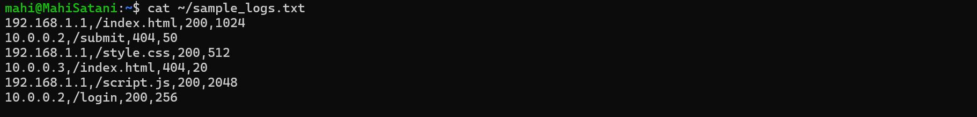
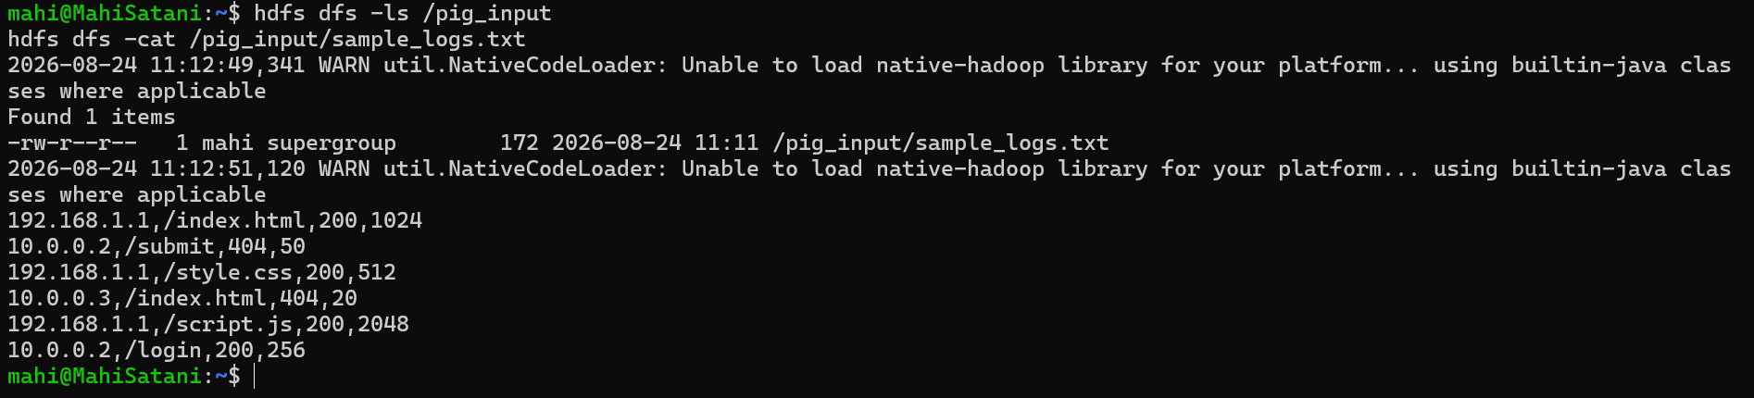
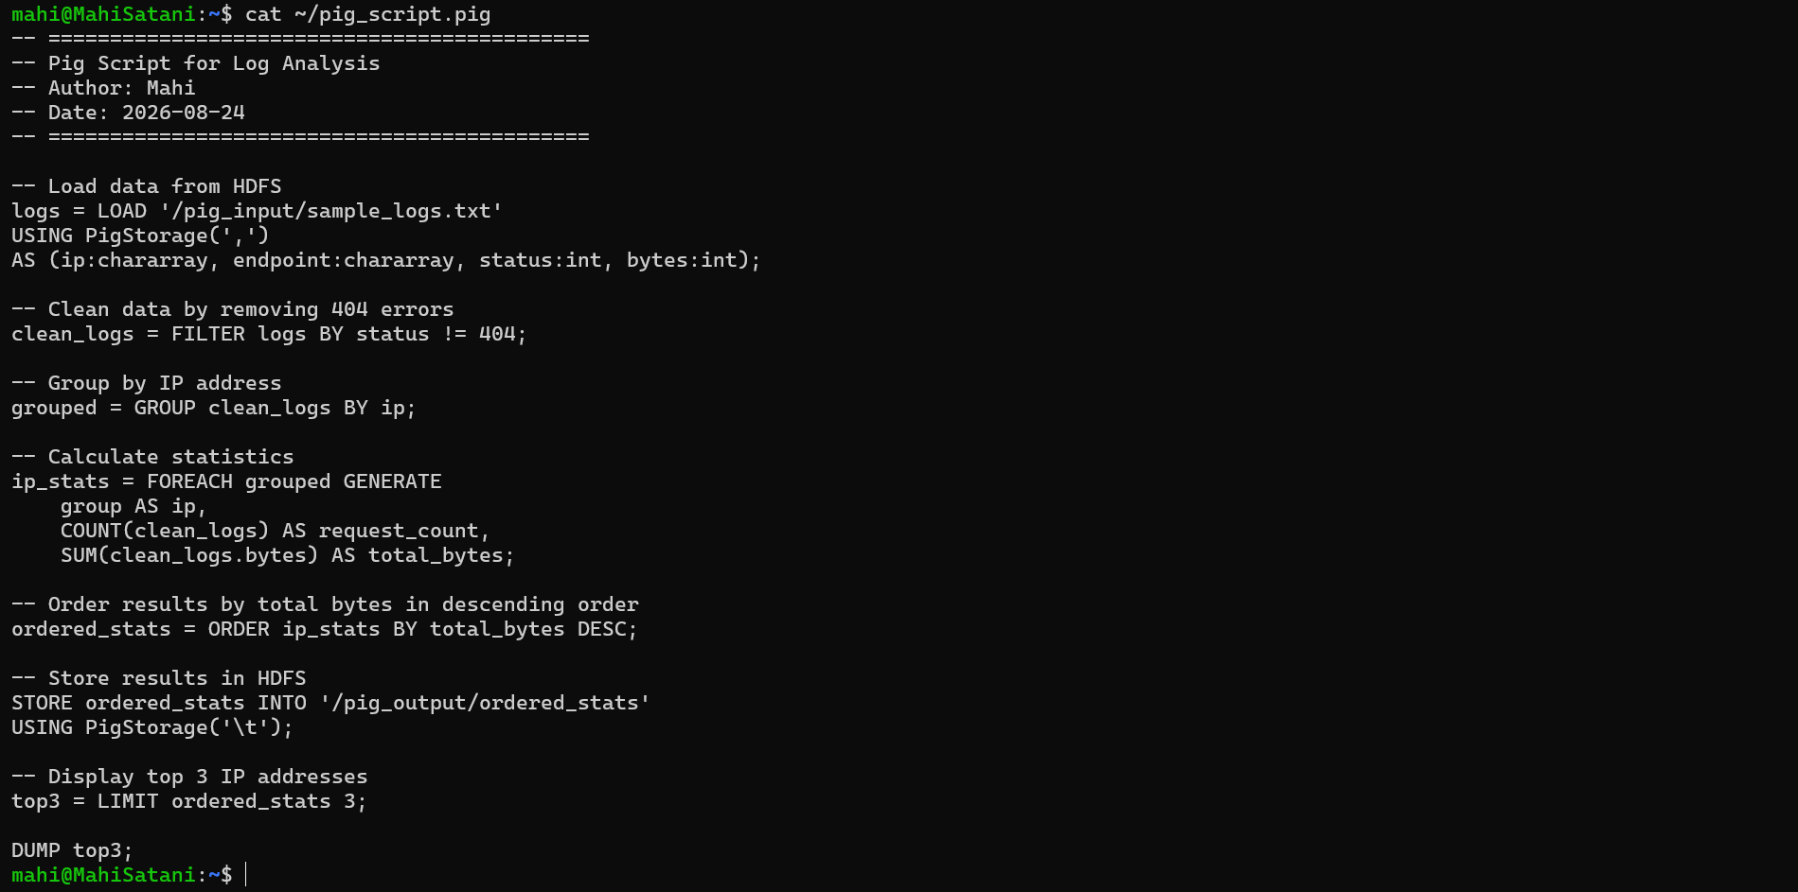

5. Conclusion
The Pig Hands-On exercise was successfully completed using Apache Pig 0.17.0 and Hadoop 3.4.2. The log data was processed in both Local Mode and Hadoop MapReduce Mode. Various Pig operations including LOAD, FILTER, GROUP, FOREACH, COUNT, SUM, JOIN, MATCHES, UPPER, ORDER, LIMIT, and STORE were successfully implemented. The final analysis calculated the number of successful requests and total bytes transferred by each IP address, and the results were successfully stored and verified in HDFS.
Overall, the exercise demonstrated how Apache Pig can simplify large-scale data processing and analysis using a high-level data-flow language.

